Name: Sohel Momin

Roll No:1513126/a4

CSS OPEN ENDED EXPERIMENT

**Program:**

%% Image Encryption using a combination of Affine and Transposition cipher

% This will use four keys. 2 for affine transformation (k1, k2)

% And other 2 for transposition along rows and columns (rowkey,columnkey)

% This program can handle both grayscale and rgb images of any size

clc;clear variables;close all;

%% Read Image

I = imread('william_ernest_henley.jpg');

dim = size(I);

[rows,columns]=deal(dim(1),dim(2));

%% Key generation (randomly)

columnkey = randperm(columns,columns);

rowkey = randperm(rows,rows);

k1 = -1;

while (k1==-1)

temp = randperm(255,1);

[mi,gcd] = mulinv(temp,256);

if gcd == 1

[k1,k1_inv] = deal(temp,mi);

end

end

k2 = randperm(255,1);

%% Encryption ( using k1,k2,rowkey,columnkey )

if length(dim)==3 % i.e if RGB image

for i = 1:columns

E1(:,i,:) = I(:,columnkey(i),:);

end

imwrite(E1,'stage1.png');

for i = 1:rows

E2(i,:,:) = E1(rowkey(i),:,:);

end

else

for i = 1:columns

E1(:,i) = I(:,columnkey(i));

end

imwrite(E1,'stage1.png');

for i = 1:rows

E2(i,:) = E1(rowkey(i),:);

end

end

imwrite(E2,'stage2.png');

E2 = double(E2(:)); % converting to double before applying affine transform

E2 = uint8(mod(E2*k1+k2,256));

E3 = reshape(E2,dim);

imwrite(E3,'encrypted.png');

%% Decryption ( using k1,k2,rowkey,columnkey )

D1 = imread('encrypted.png');

dim = size(D1);

D1 = double(D1(:)); % converting to double before applying affine transform

D1 = uint8(mod((D1-k2)*k1_inv,256));

D2 = reshape(D1,dim);

if length(dim)==3

for i = 1:dim(1)

D3(rowkey(i),:,:) = D2(i,:,:);

end

for i = 1:dim(2)

D(:,columnkey(i),:) = D3(:,i,:);

end

else

for i = 1:dim(1)

D3(rowkey(i),:) = D2(i,:);

end

for i = 1:dim(2)

D(:,columnkey(i)) = D3(:,i);

end

end

imwrite(D,'decrypted.png');

**Functions defined:**

**1) mulinv.m**

function [mi,gcd,s1,t1] = mulinv(r1,r2)

% This function calculates the greatest common divisor(gcd) of r1 & r2 and the

% multiplicative inverse(mi) of r1 in modulus of r2.

% It also returns 's1' and 't1' of the Extended Euclidean Algorithm

% 'mi' is valid only if 'gcd' == 1 !!!

[a,b,s1,s2,t1,t2] = deal(r1,r2,1,0,0,1);

while(r2 ~= 0)

q = floor(r1/r2);

r = r1-(r2*q);

s = s1-(s2*q);

t = t1-(t2*q);

[r1,r2,s1,s2,t1,t2] = deal(r2,r,s2,s,t2,t);

end

gcd = r1;

mi = mod(s1,b);

end

**Output [GRAYSCALE IMAGE]**

Input Image:-

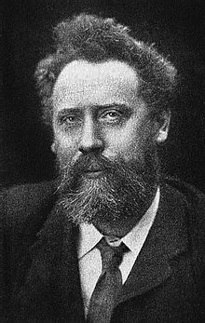

First Stage of Encryption :-

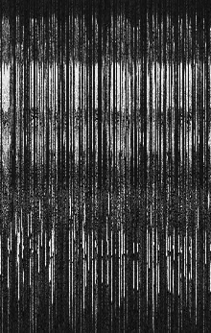

Second stage of encryption:-

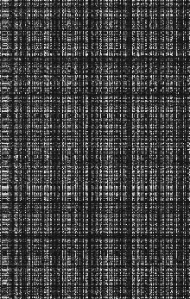

Final Stage of Encryption:-

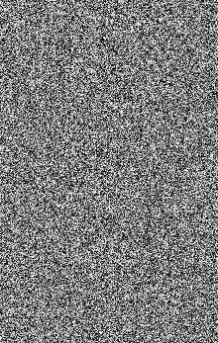

Decrypted Image:-

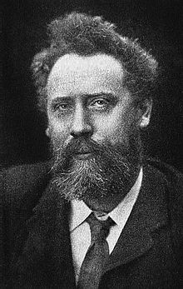

**Output [RGB IMAGE]**

Input Image:-



First Stage of Encryption :-



Second stage of encryption:-



Final Stage of Encryption:-



Decrypted Image:-

